Adaptive Heterogeneous Network and Intelligent Security Technology Research for Multi-Domain Operations
Institute of Communications Engineering 2022/06/23
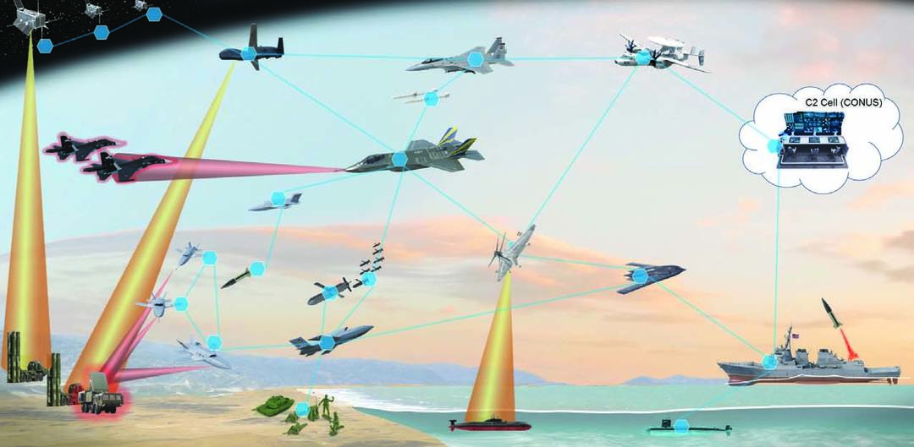

Encountering the current military confrontation in the Asia-Pacific region, Taiwan plays a key role of the Pacific first island chain under the U.S. Indo-Pacific strategy and of the People Liberation Army's anti-access. The special situation of Taiwan Strait includes characteristics of a shallow depth of battles and short response time. With an increasing number of joint operations of various vehicles and ever-changing, complicated warfare environments, the Republic of China Armed Forces need to have complex architecture and powerful computing capability for war prevention, war preparation, and future battle tactics to meet the requirements of combat diversification and speed of operations. Based on the concept of multi-domain operations (MDO) of Mosaic Warfare proposed by U.S. Defense Advanced Research Projects Agency (DAPRA), this research project entitled “Adaptive Heterogeneous Network and Intelligent Security Technology Research for Multi-Domain Operations” led by Prof. Kai-Ten Feng is expected to realize multi-year integrated breakthrough for national military defense research technology development, which includes four sub-projects: “Orchestration and Network Function Virtualization Services for Multi-Layer Networks”, “Information Delivery Management for Multi-Domain Operations Networks”, Artificial Intelligence Empowered Data Analysis and Optimization in Multi-Domain Operations Networks”, and “Adaptive Warfare Cyber Security Defense and Real-Time Response Technology”. We expect to realize the implementation of network orchestration system and heterogeneous network virtualization services with the employment of multi-layer adaptive heterogeneous network. We will establish a decision-centric warfare network along with edge computing nodes and virtualization services, which supports dynamic and distributed combat system for mission-oriented combat units to cover the whole battlefield. Moreover, with information delivery management scheme, we study tactical node deployment and multi-dimensional perception of joint caching, computing and communication resource coordination and allocation mechanism in order to achieve critical data transmission in multi-domain operations networks. Empowered by the state-of-the-art artificial intelligence (AI), the network computing architecture is capable of providing the function of self-monitoring, self-diagnosis and self-organization networks according to the mission and combat requirement. The AI combat system with the substantial operational capability can respond flexibly to the battlefield. Additionally, with the prospect of reliable cyber security detection technology under the multi-domain operations, we will design big data analysis for network security monitoring and protection. The technique ensures the security of cyberspace and increases the performance of AI automatic analysis and detection capabilities, which potentially improves the spatial and situational warfare awareness for multi-domain operations.

