**5G Campus Experimental Network**

* This project cooperates with Nokia to build a **5G campus experimental network**, including **sub-6GHz** and **28GHz millimeter wave base stations and core networks**, which can reach 1Gbps and 2Gbps downlink rates when docking with actual 5G equipment, and 31ms and 26ms end-to-end round-trip delay performance.
* Our team use the experimental network to participate in the Advantech **5G IoT special competition**, develop an IoT security detection system to detect DDoS attacks on IoT devices, and **win the** Merit Award, 2021 Advantech AIoT InnoWorks Contest.

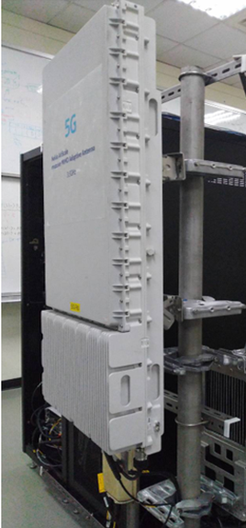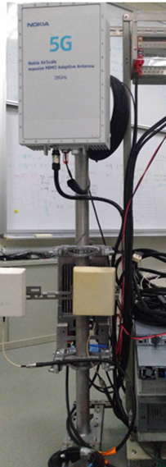

**Sub-6GHz**

**基地台**

**28GHz mmWave**

**基地台**

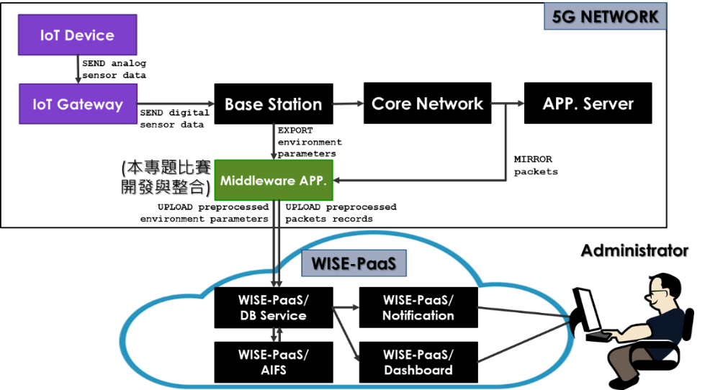

**5G Experimental Network**

* Our team adopts the O-RAN architecture to build a 5G Standalone experimental network, integrates the 5G Core and O-RAN CU, DU and RU equipment, and can provide B5G/6G standard research, Customer Premise Equipment equipment interface, 5G Mobile Edge Computing application development.
* By comparing and testing open source software core networks, simulators and other products, analyzing the gap between the developed algorithm and commercial equipment, it can provide industry testing services, reduce costs, and accelerate domestic 5G industry chain developing.
* With this experiment network, relevant research and international standards (such as the O-RAN alliance) can be interactively verified, and feedback can be given to the standards organization to enhance domestic influence in standard formulation.

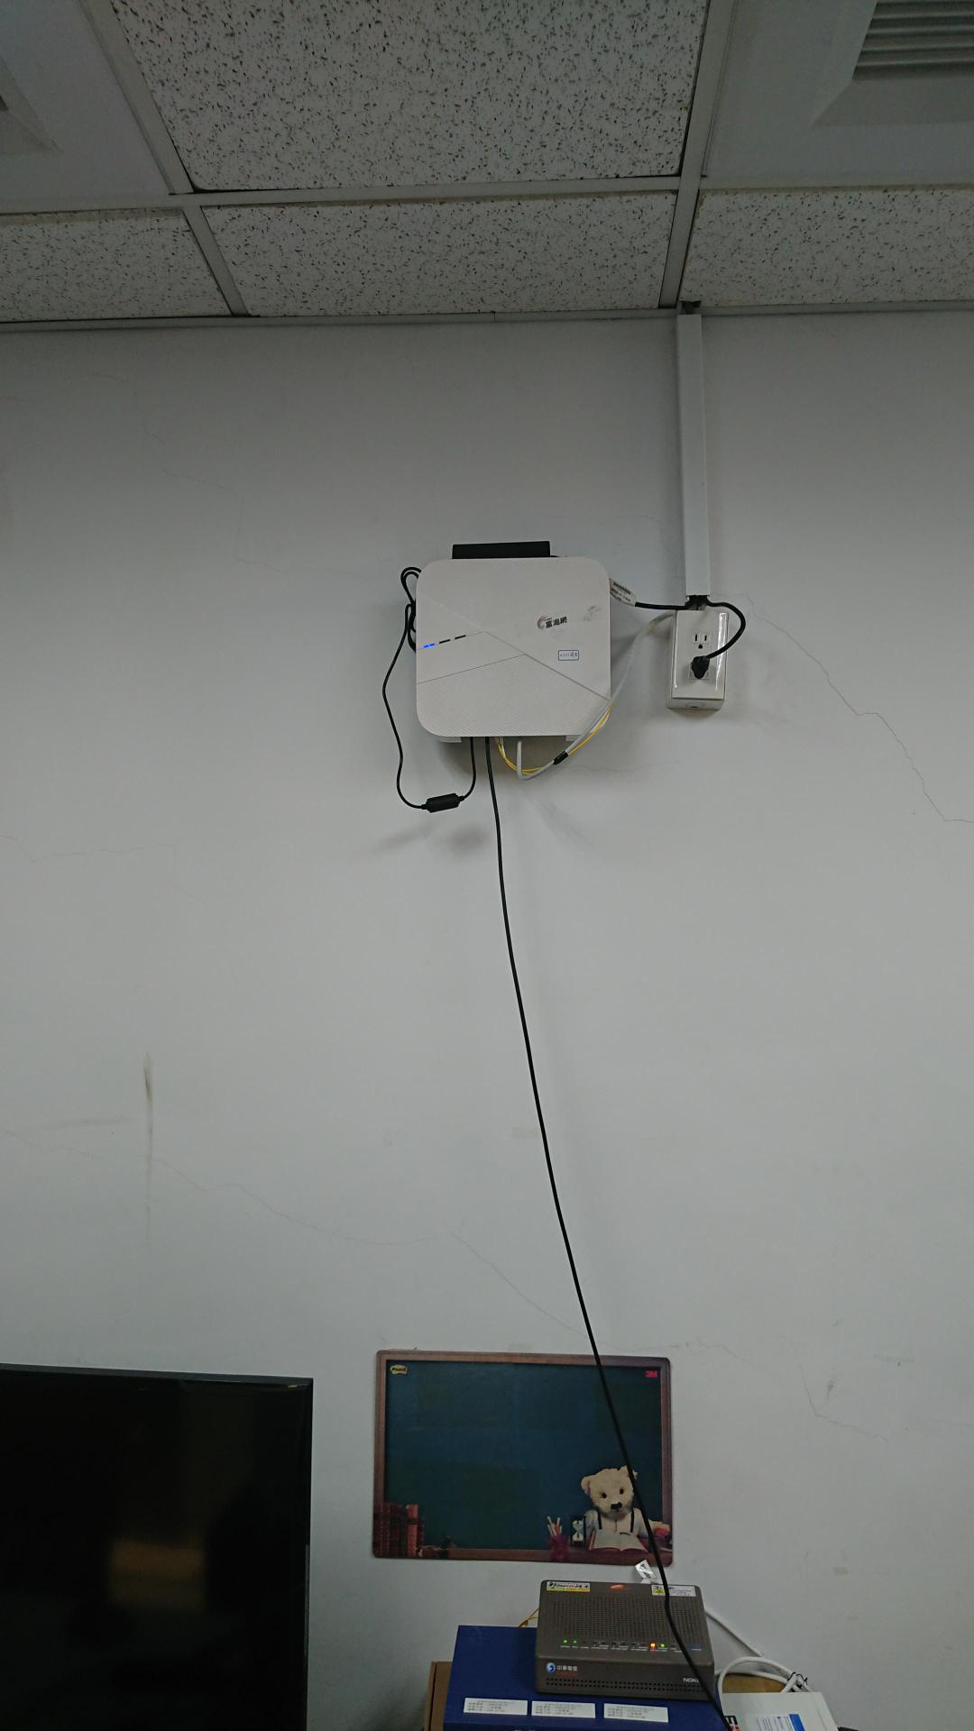

**5G Indoor RU**

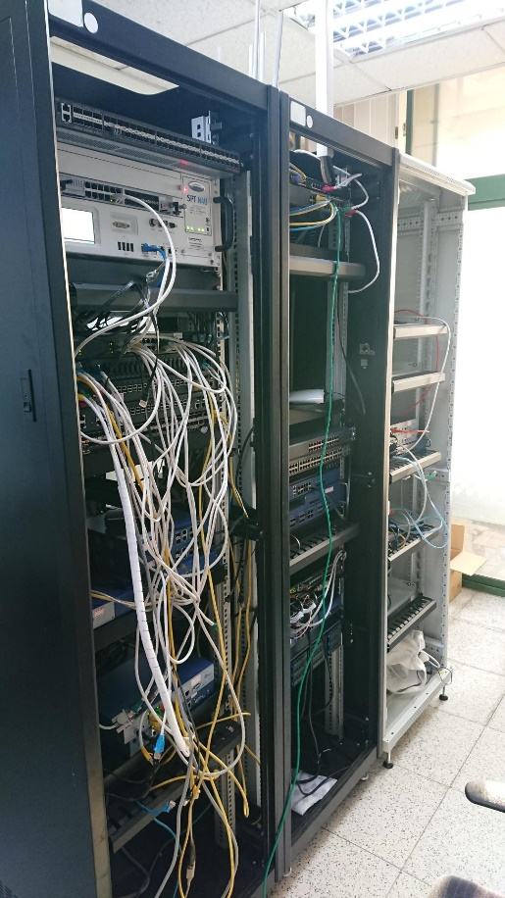

**5G Core**

**5G O-RAN CU**

**5G O-RAN DU**

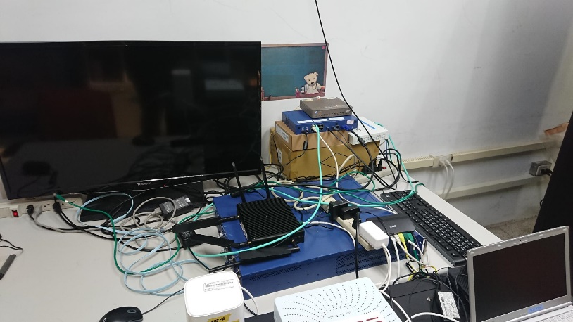

**5G O-RAN RU**

**5G CPE**

**O-RAN架構之5G SA實驗專網**